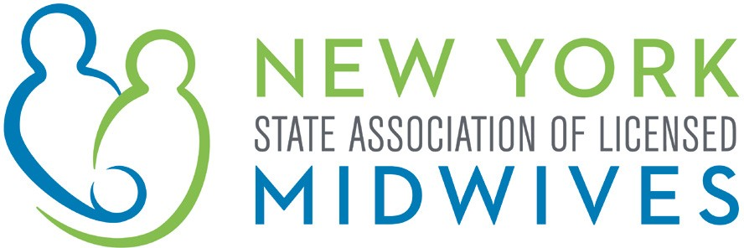

Memorandum of Support
S.7147-A (Rivera) / A.9156 (Gottfried)

AN ACT to amend the social services law, in relation to
extending the Medicaid coverage period for pregnancy

New York Midwives (“NYM”), which represents the interests of licensed midwives, as well as the welfare of women, children and families, supports the passage of S.7147-A / A.9156.

New York State has high maternal mortality and morbidity rates with clear racial disparities. In 2016 the state ranked 30th for maternal mortality, and black women are three times more likely to die from maternal mortality than white women. Recognizing the importance of providing health care coverage following a birth, the federal government provides Medicaid cost sharing and requires states to provide 60 days of coverage following a birth.

However, health care professionals agree that sixty days of health care following a birth is woefully inadequate. Best practice to reduce maternal mortality and morbidity is a year of health care coverage following a birth. In addition to the importance of supporting and fostering a new mother's physical recovery and well-being, other aspects of the first year after birth need to be addressed, i.e., adaptation by the new family of a new member, sleep deprivation, breastfeeding, behavioral changes deriving from hormonal changes and a changed marital relationship. Successful navigation of all these elements will provide the basis for her mental health since the greatest incidence of postpartum depression is known to occur at 6-12 months after birth as women go back to work and struggle with their new roles. It is also a time when women may have medical problems with breast infections, urinary incontinence, and painful intercourse. Access to birth control options at this time is another need.

At the federal level, bipartisan legislation has been introduced in Congress. The Helping Medicaid Offer Maternity Services Act would offer states incentives to make postpartum care available for one year. Several other states also have proposals to extend coverage for twelve months postpartum.

Given New York's high maternal mortality and severe maternal morbidity and racial disparities, the state must work to extend coverage for a full year to those women who would otherwise be ineligible for ongoing Medicaid payment and the services associated with that. Recognizing the current budget difficulties, this legislation directs the Commissioner of Health to immediately seek federal financial participation to provide the full year of coverage to those new mothers who currently lose coverage after 60 days. This legislation will save lives and allow children to grow up with their mothers while at the same time enhancing family quality and maternal health in many spheres.

For these reasons, NYM strongly supports the passage of S.7147-A / A.9156.

NYM 2020

