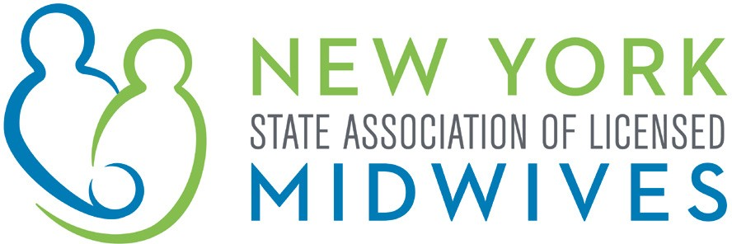

Memorandum in Support

A.5248 (Gottfried) / S.3577 (Rivera)

An act to amend the public health law and the state finance law, in relation to
enacting the "New York health act" and to establishing New York Health

The New York State Association of Licensed Midwives which represents the interests of licensed midwives, as well as the welfare of women, children and families, supports the passage of A.5248 / S.3577. This bill would create a universal single payer health plan, New York Health, to provide comprehensive health coverage for all New Yorkers.

The New York Health Plan is a single payer system with no co-payments, no premiums and no deductibles that eliminates out-of-network charges and guarantees health care access to all New Yorkers. Pregnant women need to be able to access services and support throughout their pregnancy, and this universal system would remove one of the most formidable obstacles – the financial barriers that currently exist. Access to pre- and post-natal care without the worry of financial obligations that exist in the current health care system can ultimately improve the health status of both the mother and the newborn infant. Coverage of routine gynecologic services will also help maintain women’s health status.

According to a study conducted by University of Massachusetts/Amherst Economics Department Chair Gerald Friedman, who reviewed and analyzed the New York Health Care Act, ninety-eight percent (98%) of New Yorkers would spend less for health care coverage and services by eliminating much of the bureaucracy and administrative costs borne by health care providers, employers and health care plans. The New York Health Act finances this universal health care with assessments collected by the State based on an individual or family’s ability to pay, making it affordable for all.

For these reasons, NYMidwives strongly supports the passage of A.5248 / S.3577.

NYSALM 2020

ACTIVE 42855554v1

