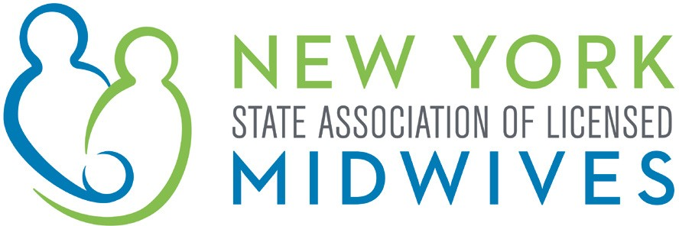

Memorandum in Support

A.4316 (Glick) / S.847 (Benjamin)

AN ACT to amend the insurance law in relation to coverage of infertility to be provided to insureds with same sex partners

The New York State Association of Licensed Midwives (“NYSALM”), which represents the interests of licensed midwives, as well as the welfare of women, children and families, supports the passage of A.4316 / S.847. This bill requires health insurance coverage of infertility to be provided to insureds with same sex partners on the same basis as that provided to insureds with a partner of the opposite sex.

NYSALM supports the core of progressive tenets of marriage equality and family equality, including the equal opportunity of every New York couple to access the necessary tools to adequately plan their families. Unfortunately, many legally married lesbian couples in New York State may be confronted with the stark realization that in their own attempts to grow their families, their insurance providers may not provide equal fertility treatments that they would be eligible for if they were in a heterosexual marriage. Many insurers who cover insemination procedures and other fertility treatments typically maintain requirements relative to a history of unsuccessful conception following heterosexual intercourse or require the use of sperm provided by a patient's partner. It is a physical impossibility for lesbians to meet these criteria. Especially following the State's legislative determination that marriage be recognized and respected in all its forms, it is wrong to allow New York's insurers to punish lesbian families based on their sexual orientation. In a just and fair world, no matter who you are, you should have the same options for the medical support to become a parent.

While New York State Law currently provides for the coverage of limited infertility testing, treatment and follow-up care, this legislation simply mandates that an insurer's infertility offerings be applied equally to all insureds who are part of a legally recognized relationship. Of note, the Insurance Law continues to recognize infertility standards as set forth by the American Society of Reproductive Medicine, which generally defines infertility as occurring after a twelve-month period of unprotected sex that does not result in conception.

Maryland similarly addressed this issue in 2015, passing legislation that addressed this inequity under their State law. Continuing in our own tradition of being a national leader on progressive issues, New York should now take the same step in avoiding a wrong.

NYSALM believes that New York should provide equal access to reproductive services for all New Yorkers regardless of their sexual orientation and strongly supports the passage of A.4316 / S.847.

NYSALM 2019

ACTIVE 42899418

