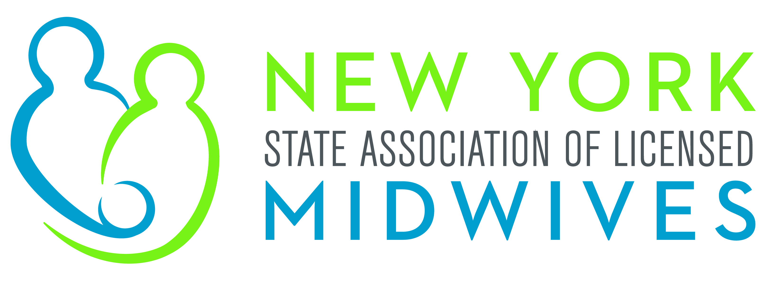
Memorandum in Support

A.2998 (Bichotte) / S.1799 (Rivera)

An Act to amend the Public Health Law, in relation to authorizing
expedited partner therapy for certain sexually transmitted infections

The New York State Association of Licensed Midwives (“NYSALM”), which represents the interests of licensed midwives, as well as the welfare of women, children and families, supports the passage of A.2998 / S.1799, which would allow for expedited partner therapy for sexually transmitted infections recommended by the Centers for Disease Control and Prevention (“CDC”) for the sexual partner or partners of someone diagnosed with the disease.

Sexually transmitted infections (“STIs”) disproportionately affect women and create a preventable threat to their fertility. One factor that contributes to young women’s high rates of STIs is reinfection from an untreated sexual partner. One way to address this problem is through expedited partner therapy (“EPT”), the practice of treating the sexual partners of patients in whom STIs are diagnosed. EPT enables a midwife or other provider to give prescriptions or medications to patients to take to their partners without first examining these partners if they are unable or unwilling to seek medical care.

In 2008, the New York State passed a law to allow health care providers with prescriptive privileges to provide EPT for Chlamydia infection when the prescriber's judgment is that the partner(s) will not seek a personal medical visit. This law has helped improve treatment rates for partners and decrease re-infection rates. This bill will expand the current law to include other sexually transmitted infections that the CDC recommends, which will help midwives and other health care providers decrease rates of sexually transmitted infections. While EPT in no way replaces a face to face interaction with a health care provider, it can help patients who otherwise would not reach out for treatment.

The CDC has found through randomized controlled tests that EPT has the potential for the same success that it has shown with Chlamydia with other STIs. EPT can be highly effective in decreasing infection rates with other STIs that can be cured by taking antibiotics by mouth, such as gonorrhea.

For these reasons, NYSALM strongly supports the passage of A.2998 / S.1799.

NYSALM 2019
ACTIVE 42843290v1

