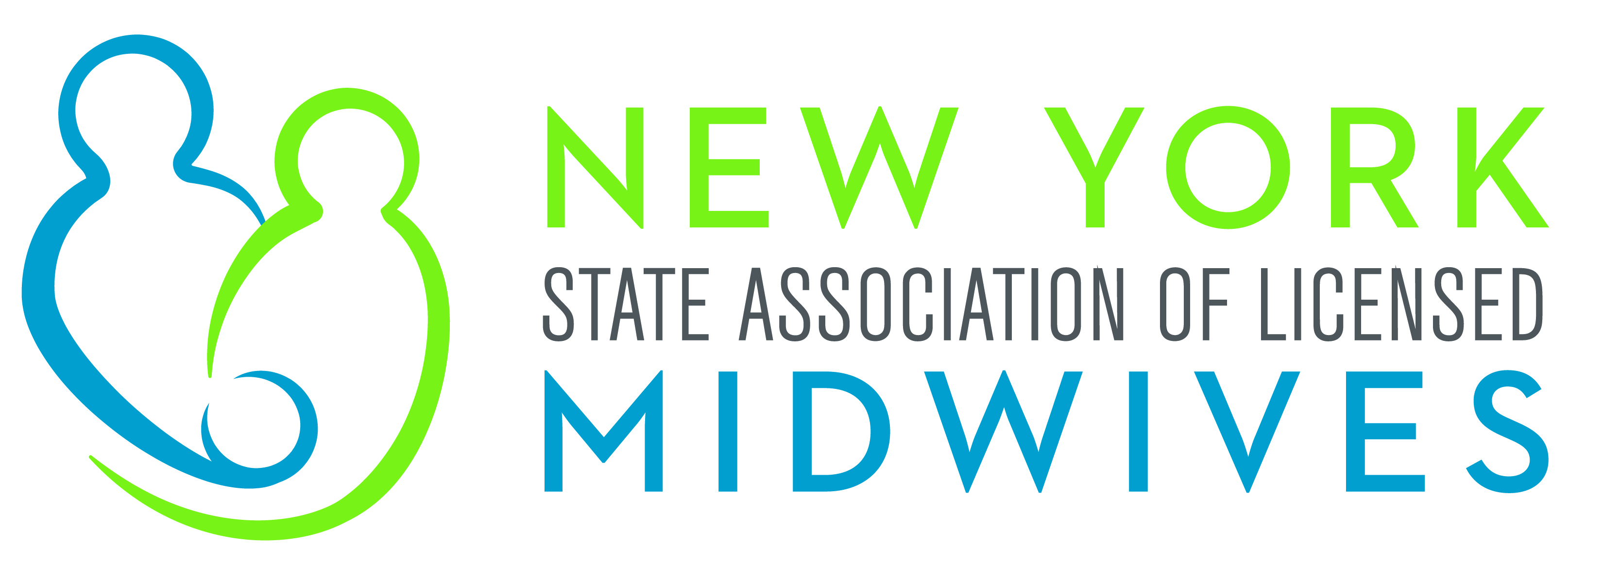

Memorandum in Support
S.4611 (Murphy)
An Act to amend the Tax Law in relation to establishing a personal income tax credit for community-based faculty clinicians who provide clinical preceptorships

The New York State Association of Licensed Midwives (“NYSALM”), which represents the interests of licensed midwives, as well as the welfare of women, children and families, supports the passage of S.4611, which establishes a clinical preceptorship personal income tax credit for health care professionals who provide community-based instruction to students.
Preceptorships provide students, including midwifery students, the opportunity for clinical training and hands-on practice in the health care field. This type of involvement allows students to gain first-hand knowledge by working directly with experienced clinicians and, in the case of midwifery, constructing a sense of self as a midwife. Students benefit and learn from such opportunities for responsibility for care under supportive supervision, hands-on learning and debriefing. A positive midwife preceptor–student relationship is an integral part of successful student midwife learning.
New York’s licensed midwives offer high quality, individualized, cost-effective care designed in the collaborative wellness model of pregnancy and birth. Licensed midwives provide primary well woman health care, including gynecologic care and care during pregnancy and childbirth, as well as care of the newborn following birth, and encourage family-centered maternal and neonatal care as well as promote and support breastfeeding. However, the demands on licensed midwives, as well as on other highly qualified healthcare professionals are substantial. There are constantly competing interests. Nonetheless, it is incumbent on these devoted individuals to provide supports for the newly educated healthcare workforce and many practitioners volunteer their time to assist with clinical training programs. This legislation acknowledges the value of New York’s existing experienced healthcare workforce, and incentivizes their participation in a preceptor program by offering participants a $1,000-$3,000 income tax credit. Enacting this bill would demonstrate New York’s commitment to ensuring midwives and other healthcare professionals are available to all the State’s communities, for many years to come.

For these reasons, NYSALM strongly supports the passage of S.4611.

