***NYS Association of Licensed Midwives*** *Presents*

**Respectful Care in a Diverse and Inclusive World**

**Saturday, November 2, 2019**

**8:00AM-4:30PM**

*Westchester Marriott Hotel*

*670 White Plains Rd., Tarrytown, NY 10591*

Topics will include respectful clinical care, issues affecting the LGBTQIA community, and reproductive care choices

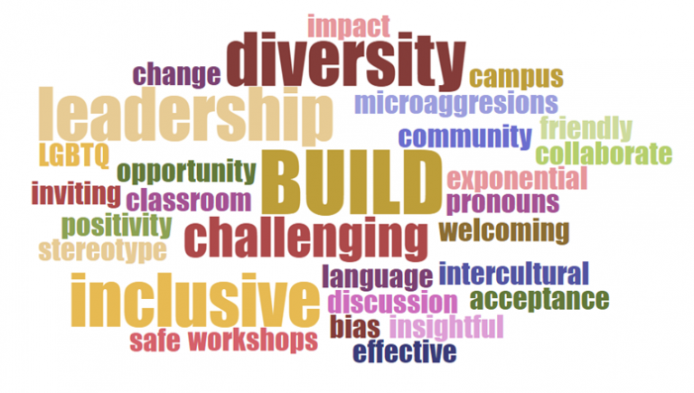

ACNM speciality credits have been applied for

Silent Auction to benefit NYSALM

**Early Bird Registration $160 by OCTOBER 8th!**

**Regular Registration $190;**

**Student & Other Birth Professionals Early Bird $50; regular $100**

**Lunch & beverage breaks included**

**To register: nysalm.ticketspice.com/nysalm-education-day**