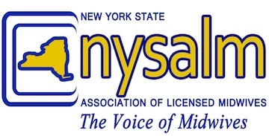

Mailing address:
C/o Lily Dalke, Treasurer
798 President Street #4R
Brooklyn NY 11215

IN KIND DONATION FORM FOR 2015

DONOR OR COMPANY NAME:_________________________________________________________

EVENT: DATE(S):

 ATTEND BOD MEETING ________-________-_______

 OTHER: _________________________________ ________-________-________

TRAVEL FROM ________________________________TO _______________________________

MILEAGE (Round Trip): ________________ x 57.5 cents per mile = $__________________

TRAIN/BUS FARE: $__________________

AIR FARE: $__________________

OTHER TRANSPORTATION COSTS:

TYPE: _____________________________________ AMOUNT $__________________

TYPE: _____________________________________ AMOUNT $__________________

FOOD: AMOUNT $__________________

ACCOMMODATIONS: AMOUNT $__________________

DONATED ITEMS:
DESCRIPTION OF ITEM (INCLUDE QUANTITIES): ______________________________________________________________________________________

______________________________________________________________________________________

ESTIMATED FAIR MARKET VALUE OF ITEM: $__________________

ESTIMATED FAIR MARKET VALUE OF ANY GOODS OR SERVICES GIVEN TO DONOR IN RETURN: $__________________

OTHER: SPECIFY______________________________ AMOUNT $__________________

OTHER: SPECIFIY _____________________________ AMOUNT $__________________

TOTAL AMOUNT $__________________

Thank you for your generous donation!
NYSALM is a 501(c)6 organization

